Regression Examples
Singh
library(readxl)
Toluca_Example1 <- read_excel("C:/Users/Pradeep Singh/Documents/Professional/CSDA5110/Fall_2024/Week5/Toluca.xlsx")
View(Toluca_Example1)

Scatter Plot
library(ggplot2)
ggplot(
data = Toluca_Example1,
mapping = aes(x = lotsize, y = workhrs)) +
geom_point() +
geom_smooth(method = "lm")
## `geom_smooth()` using formula = 'y ~ x'
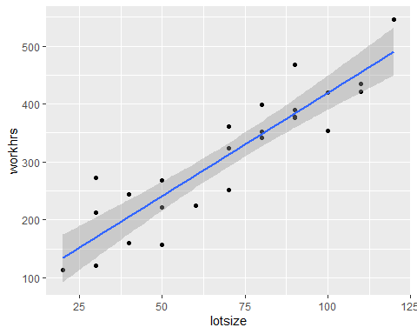

Summary Stats
summary(Toluca_Example1)
## lotsize workhrs
## Min. : 20 Min. :113.0
## 1st Qu.: 50 1st Qu.:224.0
## Median : 70 Median :342.0
## Mean : 70 Mean :312.3
## 3rd Qu.: 90 3rd Qu.:389.0
## Max. :120 Max. :546.0

Regression Coefficients
output.lm <- lm(workhrs ~ lotsize, Toluca_Example1)
output.lm
##
## Call:
## lm(formula = workhrs ~ lotsize, data = Toluca_Example1)
##
## Coefficients:
## (Intercept) lotsize
## 62.37 3.57
summary(output.lm)
##
## Call:
## lm(formula = workhrs ~ lotsize, data = Toluca_Example1)
##
## Residuals:
## Min 1Q Median 3Q Max
## -83.876 -34.088 -5.982 38.826 103.528
##
## Coefficients:
## Estimate Std. Error t value Pr(>|t|)
## (Intercept) 62.366 26.177 2.382 0.0259 *
## lotsize 3.570 0.347 10.290 4.45e-10 ***
## ---
## Signif. codes: 0 '***' 0.001 '**' 0.01 '*' 0.05 '.' 0.1 ' ' 1
##
## Residual standard error: 48.82 on 23 degrees of freedom
## Multiple R-squared: 0.8215, Adjusted R-squared: 0.8138
## F-statistic: 105.9 on 1 and 23 DF, p-value: 4.449e-10
residuals(output.lm)
## 1 2 3 4 5 6
## 51.0179798 -48.4719192 -19.8759596 -7.6840404 48.7200000 -52.5779798
## 7 8 9 10 11 12
## 55.2098990 4.0179798 -66.3860606 -83.8759596 -45.1739394 -60.2800000
## 13 14 15 16 17 18
## 5.3159596 -20.7698990 -20.0880808 0.6139394 42.5280808 27.1240404
## 19 20 21 22 23 24
## -6.6840404 -34.0880808 103.5280808 84.3159596 38.8260606 -5.9820202
## 25
## 10.7200000
fitted(output.lm)
## 1 2 3 4 5 6 7 8
## 347.9820 169.4719 240.8760 383.6840 312.2800 276.5780 490.7901 347.9820
## 9 10 11 12 13 14 15 16
## 419.3861 240.8760 205.1739 312.2800 383.6840 133.7699 455.0881 419.3861
## 17 18 19 20 21 22 23 24
## 169.4719 240.8760 383.6840 455.0881 169.4719 383.6840 205.1739 347.9820
## 25
## 312.2800
fitted.values(output.lm)
## 1 2 3 4 5 6 7 8
## 347.9820 169.4719 240.8760 383.6840 312.2800 276.5780 490.7901 347.9820
## 9 10 11 12 13 14 15 16
## 419.3861 240.8760 205.1739 312.2800 383.6840 133.7699 455.0881 419.3861
## 17 18 19 20 21 22 23 24
## 169.4719 240.8760 383.6840 455.0881 169.4719 383.6840 205.1739 347.9820
## 25
## 312.2800
##t-value
##95% confidence intervals
tval <- qt(1-0.05/2,23)
tval
## [1] 2.068658
round(confint(output.lm,level=0.95),3)
## 2.5 % 97.5 %
## (Intercept) 8.214 116.518
## lotsize 2.852 4.288

Confidence and Prediction Intervals for complete data
predict(output.lm, interval="confidence",level=0.95)
## fit lwr upr
## 1 347.9820 326.54494 369.4191
## 2 169.4719 134.36734 204.5765
## 3 240.8760 216.09481 265.6571
## 4 383.6840 358.90290 408.4652
## 5 312.2800 292.08026 332.4797
## 6 276.5780 255.14090 298.0151
## 7 490.7901 449.60756 531.9726
## 8 347.9820 326.54494 369.4191
## 9 419.3861 389.86150 448.9106
## 10 240.8760 216.09481 265.6571
## 11 205.1739 175.64938 234.6985
## 12 312.2800 292.08026 332.4797
## 13 383.6840 358.90290 408.4652
## 14 133.7699 92.58736 174.9524
## 15 455.0881 419.98350 490.1927
## 16 419.3861 389.86150 448.9106
## 17 169.4719 134.36734 204.5765
## 18 240.8760 216.09481 265.6571
## 19 383.6840 358.90290 408.4652
## 20 455.0881 419.98350 490.1927
## 21 169.4719 134.36734 204.5765
## 22 383.6840 358.90290 408.4652
## 23 205.1739 175.64938 234.6985
## 24 347.9820 326.54494 369.4191
## 25 312.2800 292.08026 332.4797
predict(output.lm,interval="prediction",level=0.95)
## Warning in predict.lm(output.lm, interval = "prediction", level = 0.95): predictions on current data refer to _future_ responses
## fit lwr upr
## 1 347.9820 244.73335 451.2307
## 2 169.4719 62.54638 276.3975
## 3 240.8760 136.88151 344.8704
## 4 383.6840 279.68959 487.6785
## 5 312.2800 209.28112 415.2789
## 6 276.5780 173.32931 379.8267
## 7 490.7901 381.71792 599.8623
## 8 347.9820 244.73335 451.2307
## 9 419.3861 314.16040 524.6117
## 10 240.8760 136.88151 344.8704
## 11 205.1739 99.94828 310.3996
## 12 312.2800 209.28112 415.2789
## 13 383.6840 279.68959 487.6785
## 14 133.7699 24.69771 242.8421
## 15 455.0881 348.16254 562.0136
## 16 419.3861 314.16040 524.6117
## 17 169.4719 62.54638 276.3975
## 18 240.8760 136.88151 344.8704
## 19 383.6840 279.68959 487.6785
## 20 455.0881 348.16254 562.0136
## 21 169.4719 62.54638 276.3975
## 22 383.6840 279.68959 487.6785
## 23 205.1739 99.94828 310.3996
## 24 347.9820 244.73335 451.2307
## 25 312.2800 209.28112 415.2789

Confidence and Prediction Intervals for Specific data points
predict(output.lm,newdata=data.frame(lotsize=c(35,45,50,65,100,110)),interval="confidence",level=0.95)
## fit lwr upr
## 1 187.3229 155.0873 219.5586
## 2 223.0249 196.0060 250.0439
## 3 240.8760 216.0948 265.6571
## 4 294.4290 273.9129 314.9451
## 5 419.3861 389.8615 448.9106
## 6 455.0881 419.9835 490.1927
predict(output.lm,newdata=data.frame(lotsize=c(35,45,50,65,100,110)),interval="prediction",level=0.95)
## fit lwr upr
## 1 187.3229 81.30465 293.3412
## 2 223.0249 118.47466 327.5752
## 3 240.8760 136.88151 344.8704
## 4 294.4290 191.36760 397.4904
## 5 419.3861 314.16040 524.6117
## 6 455.0881 348.16254 562.0136
## ANOVA table
anova(output.lm)
## Analysis of Variance Table
##
## Response: workhrs
## Df Sum Sq Mean Sq F value Pr(>F)
## lotsize 1 252378 252378 105.88 4.449e-10 ***
## Residuals 23 54825 2384
## ---
## Signif. codes: 0 '***' 0.001 '**' 0.01 '*' 0.05 '.' 0.1 ' ' 1

Read Data Example 2
(S.J. Sheather, A Modern Approach to Regression with R)
library(readxl)
anscombe <- read_excel("C:/Users/Pradeep Singh/Documents/Professional/CSDA5110/Fall_2024/Week5/anscombe.xlsx")
View(anscombe)

Four Plots for four different pairs of data
library(ggplot2)
ggplot(
data = anscombe,
mapping = aes(x = x1, y = y1)) +
geom_point() +
geom_smooth(method = "lm")
## `geom_smooth()` using formula = 'y ~ x'
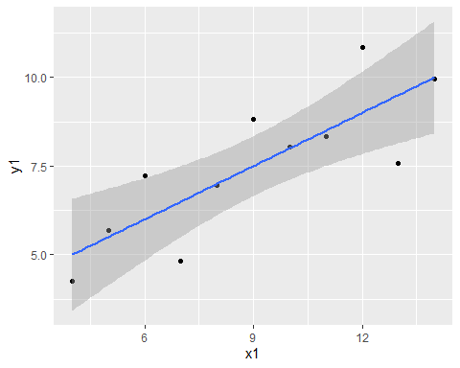
ggplot(
data = anscombe,
mapping = aes(x = x2, y = y2)) +
geom_point() +
geom_smooth(method = "lm")
## `geom_smooth()` using formula = 'y ~ x'
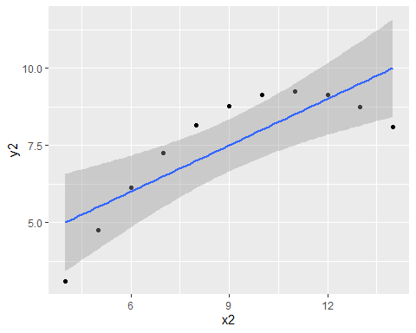
ggplot(
data = anscombe,
mapping = aes(x = x3, y = y3)) +
geom_point() +
geom_smooth(method = "lm")
## `geom_smooth()` using formula = 'y ~ x'
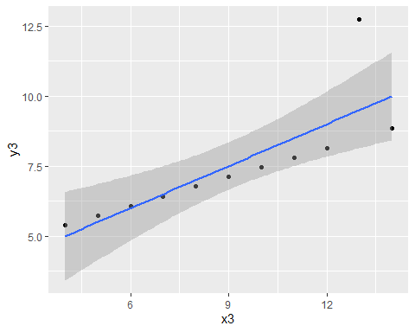
ggplot(
data = anscombe,
mapping = aes(x = x4, y = y4)) +
geom_point() +
geom_smooth(method = "lm")
## `geom_smooth()` using formula = 'y ~ x'
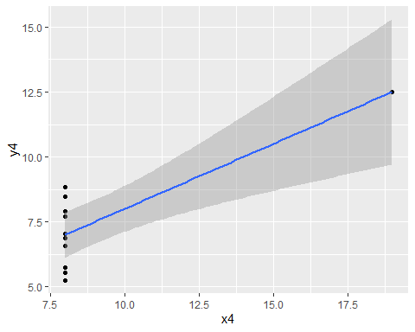
##SLR for four pairs of data
output1 <- lm(y1~x1, anscombe)
summary(output1)
##
## Call:
## lm(formula = y1 ~ x1, data = anscombe)
##
## Residuals:
## Min 1Q Median 3Q Max
## -1.92127 -0.45577 -0.04136 0.70941 1.83882
##
## Coefficients:
## Estimate Std. Error t value Pr(>|t|)
## (Intercept) 3.0001 1.1247 2.667 0.02573 *
## x1 0.5001 0.1179 4.241 0.00217 **
## ---
## Signif. codes: 0 '***' 0.001 '**' 0.01 '*' 0.05 '.' 0.1 ' ' 1
##
## Residual standard error: 1.237 on 9 degrees of freedom
## Multiple R-squared: 0.6665, Adjusted R-squared: 0.6295
## F-statistic: 17.99 on 1 and 9 DF, p-value: 0.00217
output2 <- lm(y2~x2, anscombe)
summary(output2)
##
## Call:
## lm(formula = y2 ~ x2, data = anscombe)
##
## Residuals:
## Min 1Q Median 3Q Max
## -1.9009 -0.7609 0.1291 0.9491 1.2691
##
## Coefficients:
## Estimate Std. Error t value Pr(>|t|)
## (Intercept) 3.001 1.125 2.667 0.02576 *
## x2 0.500 0.118 4.239 0.00218 **
## ---
## Signif. codes: 0 '***' 0.001 '**' 0.01 '*' 0.05 '.' 0.1 ' ' 1
##
## Residual standard error: 1.237 on 9 degrees of freedom
## Multiple R-squared: 0.6662, Adjusted R-squared: 0.6292
## F-statistic: 17.97 on 1 and 9 DF, p-value: 0.002179
output3 <- lm(y3~x3, anscombe)
summary(output3)
##
## Call:
## lm(formula = y3 ~ x3, data = anscombe)
##
## Residuals:
## Min 1Q Median 3Q Max
## -1.1586 -0.6146 -0.2303 0.1540 3.2411
##
## Coefficients:
## Estimate Std. Error t value Pr(>|t|)
## (Intercept) 3.0025 1.1245 2.670 0.02562 *
## x3 0.4997 0.1179 4.239 0.00218 **
## ---
## Signif. codes: 0 '***' 0.001 '**' 0.01 '*' 0.05 '.' 0.1 ' ' 1
##
## Residual standard error: 1.236 on 9 degrees of freedom
## Multiple R-squared: 0.6663, Adjusted R-squared: 0.6292
## F-statistic: 17.97 on 1 and 9 DF, p-value: 0.002176
output4 <- lm(y4~x4, anscombe)
summary(output4)
##
## Call:
## lm(formula = y4 ~ x4, data = anscombe)
##
## Residuals:
## Min 1Q Median 3Q Max
## -1.751 -0.831 0.000 0.809 1.839
##
## Coefficients:
## Estimate Std. Error t value Pr(>|t|)
## (Intercept) 3.0017 1.1239 2.671 0.02559 *
## x4 0.4999 0.1178 4.243 0.00216 **
## ---
## Signif. codes: 0 '***' 0.001 '**' 0.01 '*' 0.05 '.' 0.1 ' ' 1
##
## Residual standard error: 1.236 on 9 degrees of freedom
## Multiple R-squared: 0.6667, Adjusted R-squared: 0.6297
## F-statistic: 18 on 1 and 9 DF, p-value: 0.002165

Residual plots
ggplot(
data = output1,
mapping = aes(x = x1, y = output1$residuals)) +
geom_point()
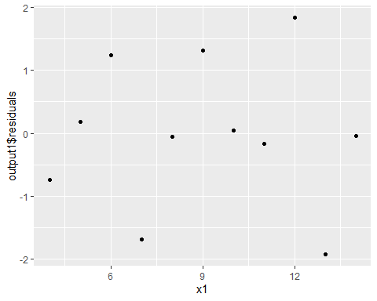
ggplot(
data = output2,
mapping = aes(x = x2, y = output2$residuals)) +
geom_point()
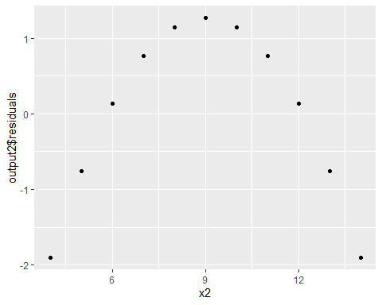
ggplot(
data = output3,
mapping = aes(x = x3, y = output3$residuals)) +
geom_point()
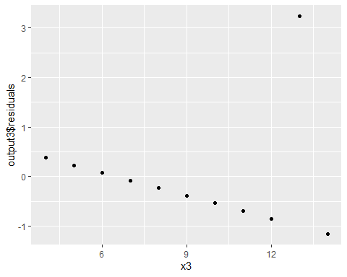
ggplot(
data = output4,
mapping = aes(x = x4, y = output4$residuals)) +
geom_point()
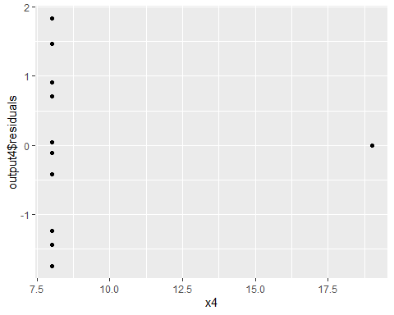

Normal Probablity plot and other plots
plot(output1)
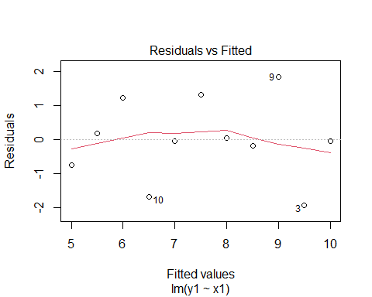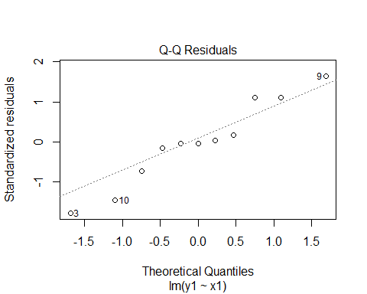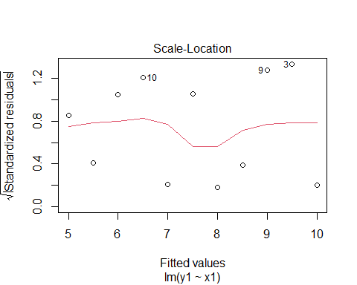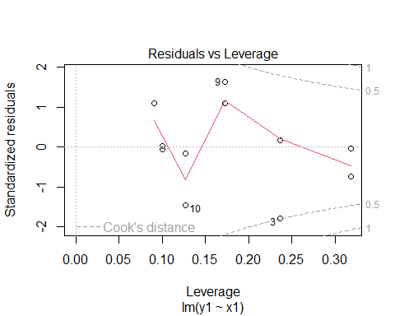
plot(output2)
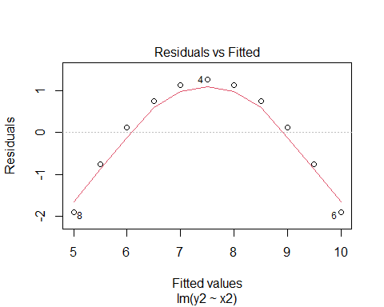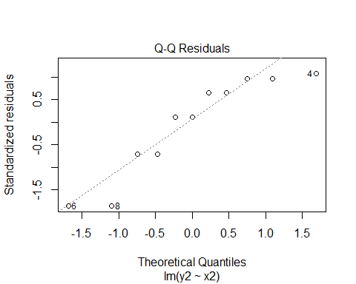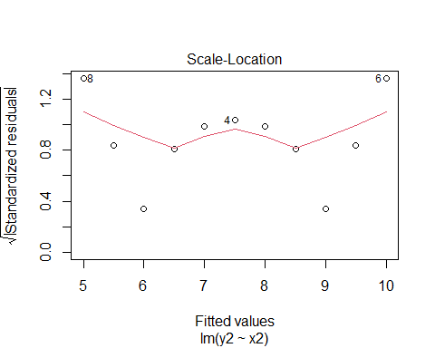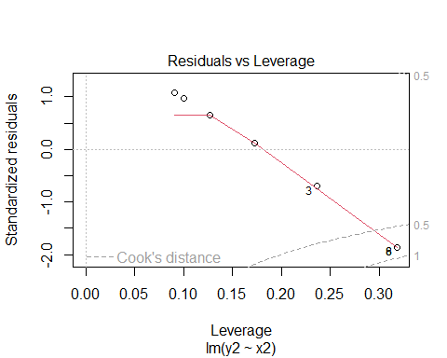
plot(output3)
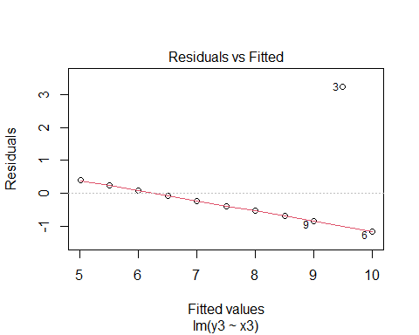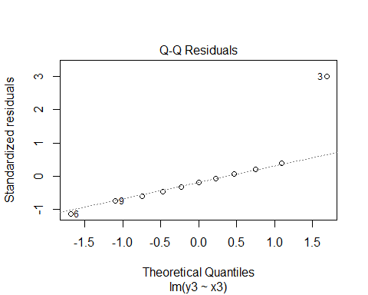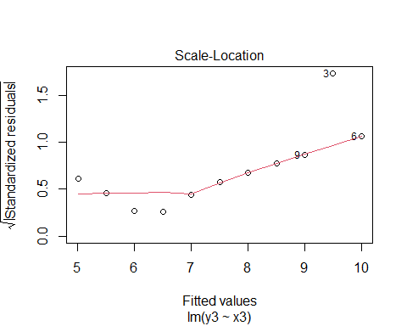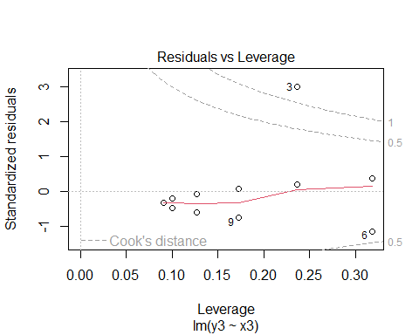
plot(output4)
## Warning: not plotting observations with leverage one:
## 8
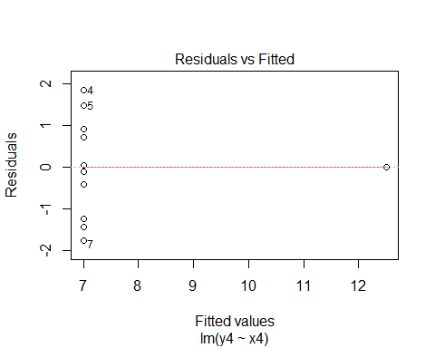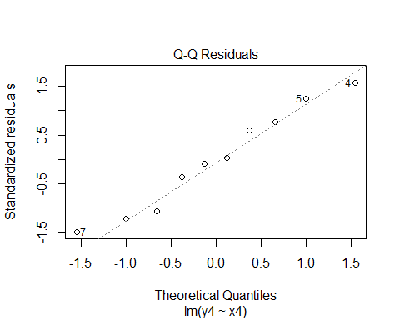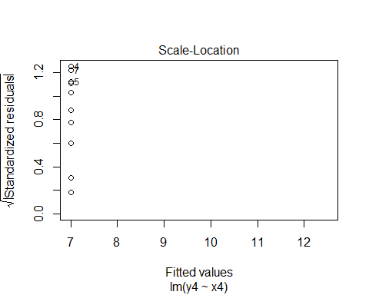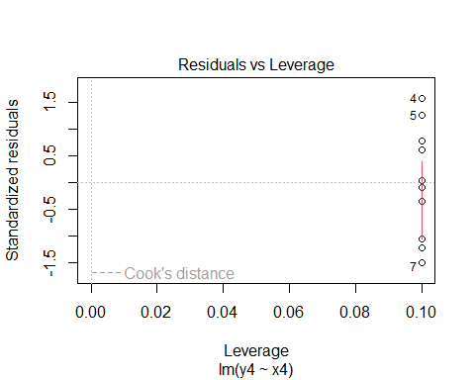 ## Multiple Linear Regression
library(readxl)
Ital_Restau <- read_excel("C:/Users/Pradeep Singh/Documents/Professional/CSDA5110/Fall_2024/Week5/nyc.xlsx")
head(Ital_Restau)
## # A tibble: 6 × 7
## Case Restaurant Price Food Decor Service East
## <dbl> <chr> <dbl> <dbl> <dbl> <dbl> <dbl>
## 1 1 Daniella Ristorante 43 22 18 20 0
## 2 2 Tello's Ristorante 32 20 19 19 0
## 3 3 Biricchino 34 21 13 18 0
## 4 4 Bottino 41 20 20 17 0
## 5 5 Da Umberto 54 24 19 21 0
## 6 6 Le Madri 52 22 22 21 0
data_restau <-Ital_Restau[,c(-1,-2,-7)]
data_restau
## # A tibble: 168 × 4
## Price Food Decor Service
## <dbl> <dbl> <dbl> <dbl>
## 1 43 22 18 20
## 2 32 20 19 19
## 3 34 21 13 18
## 4 41 20 20 17
## 5 54 24 19 21
## 6 52 22 22 21
## 7 34 22 16 21
## 8 34 20 18 21
## 9 39 22 19 22
## 10 44 21 17 19
## # ℹ 158 more rows

MLR Estimation
library(api2lm)
output.lm <- lm(Price ~ Food+Decor+Service+East, Ital_Restau)
output.lm
##
## Call:
## lm(formula = Price ~ Food + Decor + Service + East, data = Ital_Restau)
##
## Coefficients:
## (Intercept) Food Decor Service East
## -24.023800 1.538120 1.910087 -0.002727 2.068050
anova(output.lm)
## Analysis of Variance Table
##
## Response: Price
## Df Sum Sq Mean Sq F value Pr(>F)
## Food 1 5670.3 5670.3 172.2269 < 2e-16 ***
## Decor 1 3223.7 3223.7 97.9142 < 2e-16 ***
## Service 1 3.9 3.9 0.1192 0.73037
## East 1 157.1 157.1 4.7716 0.03036 *
## Residuals 163 5366.5 32.9
## ---
## Signif. codes: 0 '***' 0.001 '**' 0.01 '*' 0.05 '.' 0.1 ' ' 1
summary(output.lm)
##
## Call:
## lm(formula = Price ~ Food + Decor + Service + East, data = Ital_Restau)
##
## Residuals:
## Min 1Q Median 3Q Max
## -14.0465 -3.8837 0.0373 3.3942 17.7491
##
## Coefficients:
## Estimate Std. Error t value Pr(>|t|)
## (Intercept) -24.023800 4.708359 -5.102 9.24e-07 ***
## Food 1.538120 0.368951 4.169 4.96e-05 ***
## Decor 1.910087 0.217005 8.802 1.87e-15 ***
## Service -0.002727 0.396232 -0.007 0.9945
## East 2.068050 0.946739 2.184 0.0304 *
## ---
## Signif. codes: 0 '***' 0.001 '**' 0.01 '*' 0.05 '.' 0.1 ' ' 1
##
## Residual standard error: 5.738 on 163 degrees of freedom
## Multiple R-squared: 0.6279, Adjusted R-squared: 0.6187
## F-statistic: 68.76 on 4 and 163 DF, p-value: < 2.2e-16
##Pairwise Correlation
library(api2lm)
library(lmSubsets)
library(olsrr)
##
## Attaching package: 'olsrr'
## The following object is masked from 'package:datasets':
##
## rivers
library(car)
## Loading required package: carData
pairs( ~ Price+Food+Decor+Service+East, Ital_Restau)
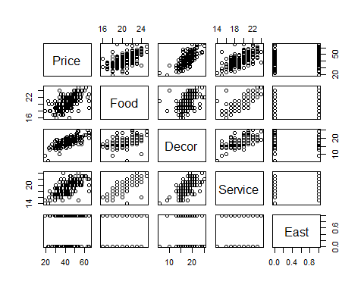
cor(data_restau)
## Price Food Decor Service
## Price 1.0000000 0.6270435 0.7243525 0.6411402
## Food 0.6270435 1.0000000 0.5039161 0.7945248
## Decor 0.7243525 0.5039161 1.0000000 0.6453306
## Service 0.6411402 0.7945248 0.6453306 1.0000000

ANOVA Table
anova(output.lm)
## Analysis of Variance Table
##
## Response: Price
## Df Sum Sq Mean Sq F value Pr(>F)
## Food 1 5670.3 5670.3 172.2269 < 2e-16 ***
## Decor 1 3223.7 3223.7 97.9142 < 2e-16 ***
## Service 1 3.9 3.9 0.1192 0.73037
## East 1 157.1 157.1 4.7716 0.03036 *
## Residuals 163 5366.5 32.9
## ---
## Signif. codes: 0 '***' 0.001 '**' 0.01 '*' 0.05 '.' 0.1 ' ' 1

